**LAB # 07**

**Open Ended Lab**

**Open-Ended Lab Task: GitHub Integration, Code Optimization, and Concurrency in Java**

**Objective**:

In this lab, you will explore essential practices for version control using GitHub, practice code optimization techniques, and understand multithreading and inter-thread communication in Java.

**Lab Task :**

In this lab, you are task with designing and implementing a multithreaded application based on any real-world scenario of your choice. Your chosen scenario should involve multiple tasks or processes running concurrently, where synchronization is critical to ensure smooth and error-free operation. Examples could include a real-time task assignment system, an e-commerce order processing system, an online examination system, or a banking transaction management system. You must implement multithreading using thread lifecycle methods such as start, sleep, and stop and ensure thread safety through synchronization techniques like synchronized blocks, synchronized methods. After creating the application, focus on optimizing your code by removing redundancies, improving resource efficiency, and following good coding practices like meaningful variable names, and proper commenting. Once the application is complete, upload your project to GitHub, create separate branches for different features or improvements, and perform branch merge operations. Finally, clone your repository into Eclipse IDE, make any final changes, and push the updates back to GitHub. This lab allows you the freedom to choose your scenario and encourages creativity while reinforcing concepts like multithreading, synchronization, code optimization, and version control workflows.

**SOL:**

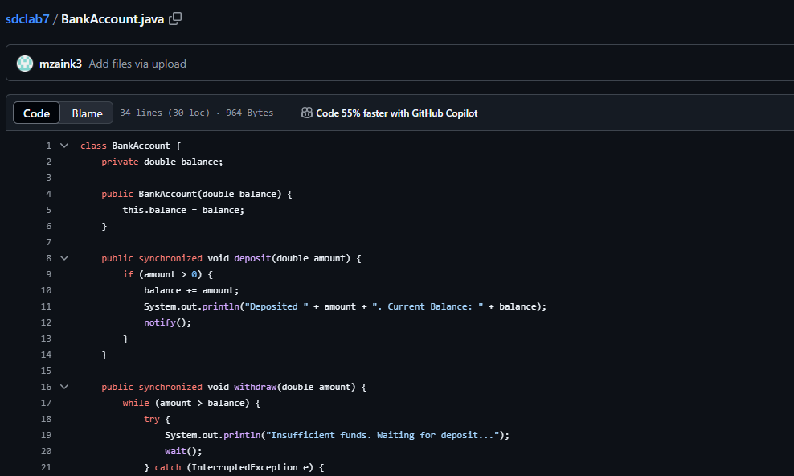

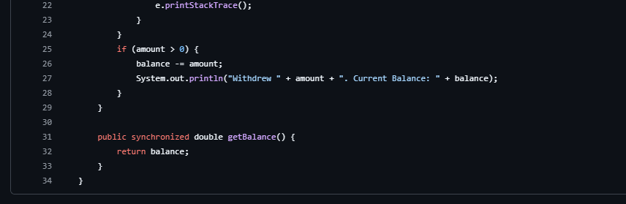

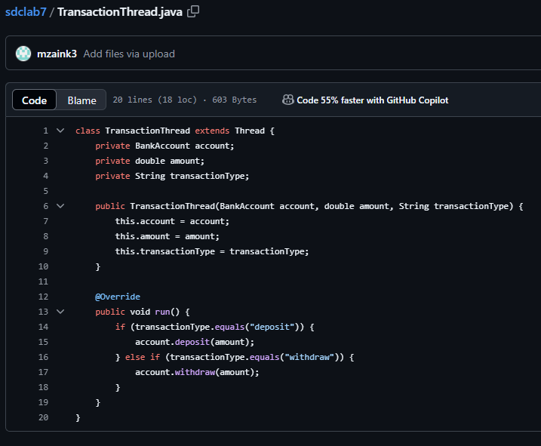

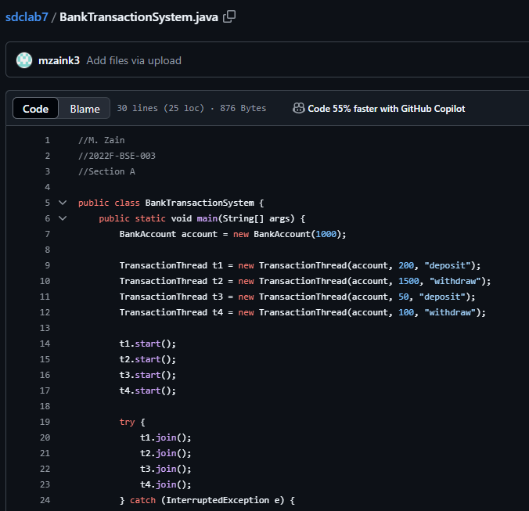

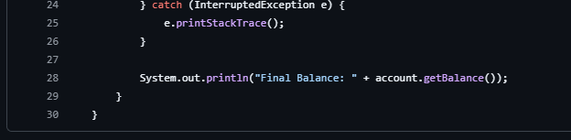

**OUTPUT:**

